Welcome to the Clarity - Choice – Change
Bundle of Focus

This is your month to get clear, make better choices and experience wonderful change.

Let’s Get Started!

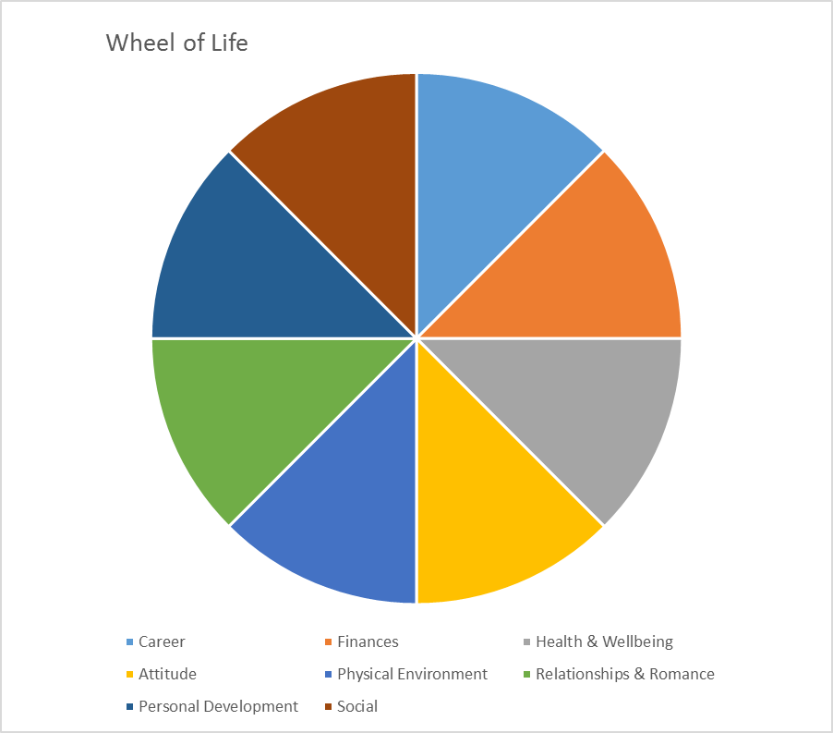
Take the Wheel of Life below and you will see 8 Areas of your Life. Fill out this wheel by giving yourself a grade out of 10 for each area. 0 being the Lowest and 10 being the Highest.
(eg. Career: 5/10)

Write these out below:
Career: /10
Attitude: /10
Personal Development: /10
Finances: /10
Physical Environment (Home): /10
Social/Hobbies: /10
Health & Wellbeing: /10
Relationships
Friends, Family & Romance: /10

Please feel free to add anything to your list:

Now taking each area let’s do the following:

Clarity Questions:

What is not working for you at this time?
What is not working for you?
Why do you feel it is not working?
How is this area of your life making you feel emotionally?
What is working for you in this area?
What are the positives?

Choice Questions:

What decisions and choices are you making currently that you know are not helping you progress in this area?
What decisions and choices do you know you need to make at this time to make things better for you? Even if those choices may be hard to actually do.
Are you choosing to love yourself in this area of your life?
If yes, why?
If no, why?
What benefit will there be to looking after yourself and making better choices for yourself?

Change Questions:

What action steps do you need to make to see changes happening?
What limiting beliefs do you need to let go of to progress?
What has been holding you back emotionally from making these changes?
What circumstances/situations have been holding you back from making change?
Why do you want change in this area?

You CAN Do This!

