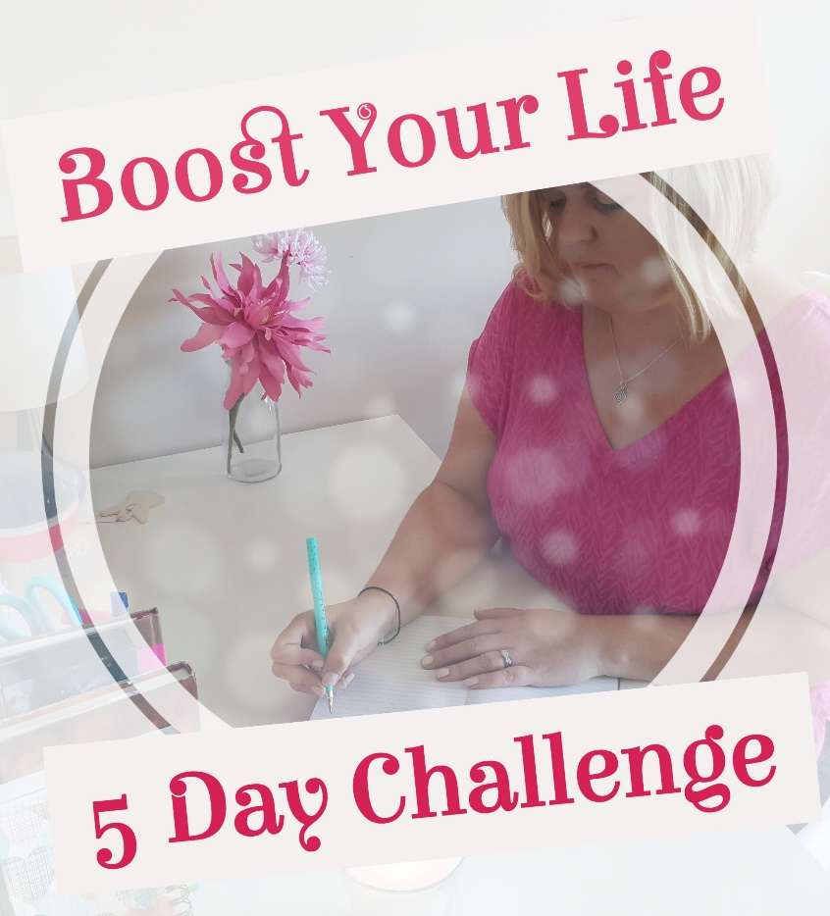

Welcome to Day 3 of the Boost Your Life - 5 Day Challenge. Well done on all the work you have done for the past few days because digging deep can be difficult and taking time to write your thoughts out on paper also requires commitment, so you are brilliant to have done it.

Today, it is all about getting creative and after you listen to the video for today you can get creating!! This is where you can let your imagination run wild. Don’t limit yourself. Don’t hold yourself back. They say ‘anything is possible’ and I believe this is true when we take inspired action, surrender, trust and break your goals down into small steps.

Enjoy today and see you tomorrow!

Caroline x

Get Creative

This is your time now to use this workbook as your bank canvas. Before you begin, I would suggest taking a few minutes to sit with your eyes closed, relax your body and take some deep breaths in and out. Allow the body and mind to relax and then get ready to create your life through colour, pictures and words.

You can use the workbook to write words out, stick pictures on this page, draw images or symbols…anything that feels good to you and represents what you want to start creating in your life.

After you do this, scroll down through this workbook for the section on Inspired Action.

My Life Canvas

Inspired Action

I hope you had great fun getting creative by tapping into your visions and allowing your youthful side to come out while you made your life’s canvas.

Next, I would like you to write out action steps you have taken previously to achieve goals but they didn’t work because you didn’t enjoy them.

Finally, now write out what action steps you can begin to take towards achieving the goals on your canvas that will feel good and enjoyable.

Copyright: Caroline Maria Meade 2018

