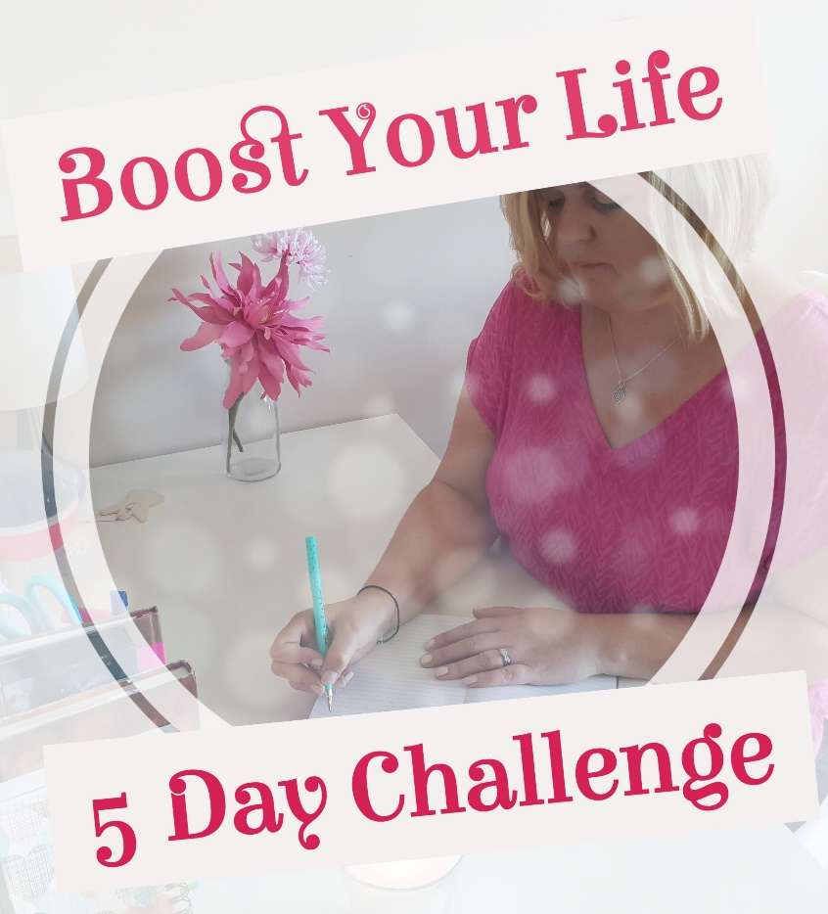

Welcome to Day 5 of the Boost Your Life - 5 Day Challenge. You have reached the final day and seriously, well done on getting this far as you have covered a lot of work in a short period of time.

As you finish off it is important to look forward to all the wonderful things you are going to create and achieve by giving time to Consistency & Commitment.

I have spoken about this in today’s video and I hope you enjoy today’s workbook.

Caroline x

P.S. If you would like daily support direct to your phone every day via text message, come on over and join http://www.itstimeforme.ie

My Letter of Commitment
(Write a letter to yourself detailing all the things you will do.)

Dear Me,

On this day the ______ day of ___________ 2018 I commit to fully look after myself and to ensure that my self-care is a priority. I commit to the dreams I have and the life I want to maintain and create by doing…….

Signed: _____________________________

Consistency
The ways in which I will be consistent and have a better structure are:

Copyright: Caroline Maria Meade 2018

