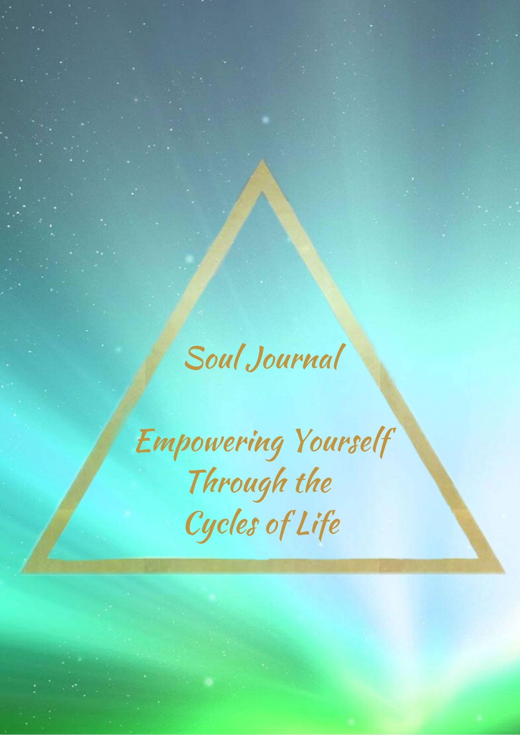
Empowering Yourself Through the Cycles of Life

When you think of a typical month, what emotions or moods do you find yourself experiencing?

For each emotion or mood you have listed, I would like you to write down how this affects your daily life (positively and negatively)?

If you have a monthly menstrual cycle are you aware of the times each month that you are affected by this?

If yes, write more about what you notice?

I would love you to start bringing your awareness to your cycles, by keeping a short note of each of the 4 weeks of your cycle.
Week 1:
Week 2:
Week 3:
Week 4:

When you feel positive, what things do you do in your life? (e.g. take action steps towards goals, have more fun, etc.)

When you feel negative, what things do you do in your life? (e.g. procrastinate, hibernate, sabotage yourself, etc.)

How do you think you can start honoring these positive and negative cycles more? (e.g. stop putting yourself under pressure, take time out, etc.)

My plan to honor my cycles:

Join me on Thursday 20th February at 9pm (GMT Ireland/UK) and we will create a beautiful plan to help you to be empowered and keep progressing through all your cycles. Have this journal at hand for the Soul Circle Class.

Well done on completing your Soul Workbook for February. This will make a huge difference to the way you approach life

