Self-Care in Adversity

My hope for this month’s Soul Journal is for you to allow yourself to go on a path of self-discovery. There are deep reasons why we and our planet are experiencing these changes. We owe it to ourselves and each other to step into ourselves and step up. I also would like this journal to help you focus on all the things you can do for yourselves during times you have to stay at home.

My biggest fears at this time are:

Health Fears:

Fears for Others:

Financial Fears:

Job/Business Fears:

Fears of the Unknown:

For each of these areas, I would now like you to write out the good things about these:
[You may be experiencing a loss in some of these areas but I would like you to find even one good things about each area.]

The good aspects of my health are:

The good aspects of my loved ones’ health are:

The good aspects of my finances right now are:

The good aspects of my job/business are:

The good aspects of not knowing what the future is are:

When these fears begin in your mind, where in your body do you experience the fear? (e.g. nervous stomach, no appetite, tight chest etc.)

My suggestion now is to listen to the meditations provided, especially the Breathe meditation to help recentre you.
Fear is worrying about the future, whether that is what will happen in 2 hours or over the next 2 months. The mind takes us into our worst case scenario. We all do this and especially at the moment, this is normal.
The most important thing we can do is to acknowledge our fears. Don’t surpress these as you will feel worse in the long run. Acknowledge them and let’s find a way of getting a plan in place now to help ease these and keep us moving forward.

When I feel fear, what will be my go-to actions to release this?
(e.g. meditation, simply sitting and just breathing deeply to rebalance, going for a walk, ringing someone, journaling, etc.)
Make a decision now what you will do but please do make the actions ones that you will actually do.

As we move from fear, we now need to look at what needs healing in our lives because at the time we can get triggered and our healing comes up for attention more and more.

The parts of my healing that I have been avoiding are:
(e.g. sabotage, self-doubt, over eating etc.)

I need to heal this because:
(You may have a few areas, so take each area separately).

Now choose one of the areas that needs to be healed and let’s look at it deeper.

This is how the process works:
e.g. I over eat.
Why?
Because I feel I am not good enough.
Why?
Because I need to make changes?
Why?
Because I don’t like the way things are?
Why?
Because I keep doing things that are not good for me.
Why?
Because I want to sabotage.
Why?
Because I believe I don’t deserve to enjoy the good things in life.
Why?
Because I was always told that I am not good enough.

We see in this case that the over eating is a manifestation of deeper emotions, which started because they were told they weren’t good enough.

This is just an example, I would like you to follow this process and keep asking the question why until you get to the core of the issue and that is then what needs to be healed.

The ‘why process’…..
(Please complete your own ‘why process’ below)

Write out a list of things that you like about yourself and the positive things people say about you and to you.

Take time over the coming weeks to keep reading this sheet and understanding why you feel the way you do but remembering all the reasons you are great.
My new Daily Practices

As things are now changing in the world, you may be working from home, you may be indoors a lot and you may just be wanting to reconnect more, it is important that you create a good and solid daily practice to keep yourself balanced and at peace.
[E.g. 5 minute grounding exercise in the morning.
Online Yoga Class.
Starting a new project.
Choosing one news channel at one time during the day and only watch media for a max of one hour a day.
Unfollow people or pages spreading negative information on social media and start following positive, uplifting and motivating pages.
Exercise.
Watch comedies.
Laugh.
Do video chats with friends. Virtual socialising but plan it as if you were planning nights out/things to do.
Get creative – drawing, painting, healing, etc.]

My new daily practices are……

I would like you now to free write. Set a time for 5 to 10 minutes. Read the statement below and then just write whatever comes to mind until the timer stops.

Everything that is happening now is happening for deep spiritual and universal reasons. The reasons it is happening for me are……

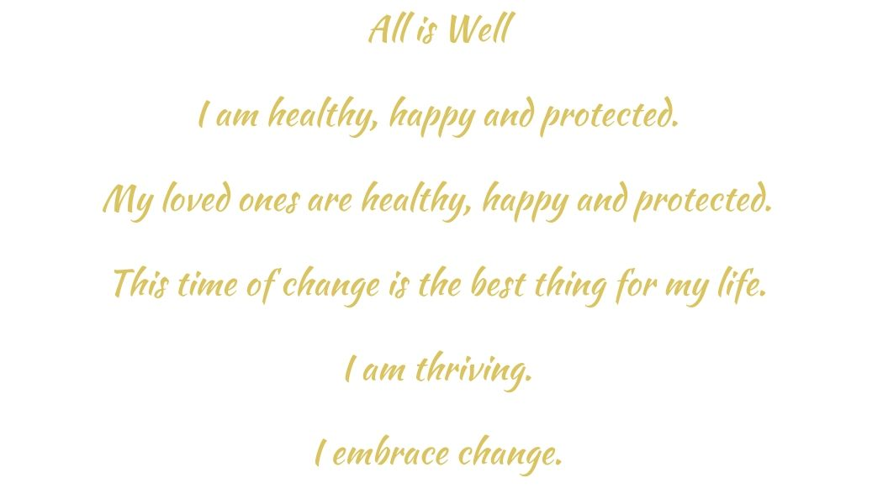

You will get through this. Mind yourself, mind each other and remember, this is a gift of time we will probably never experience again in our lifetime. You are ready!

