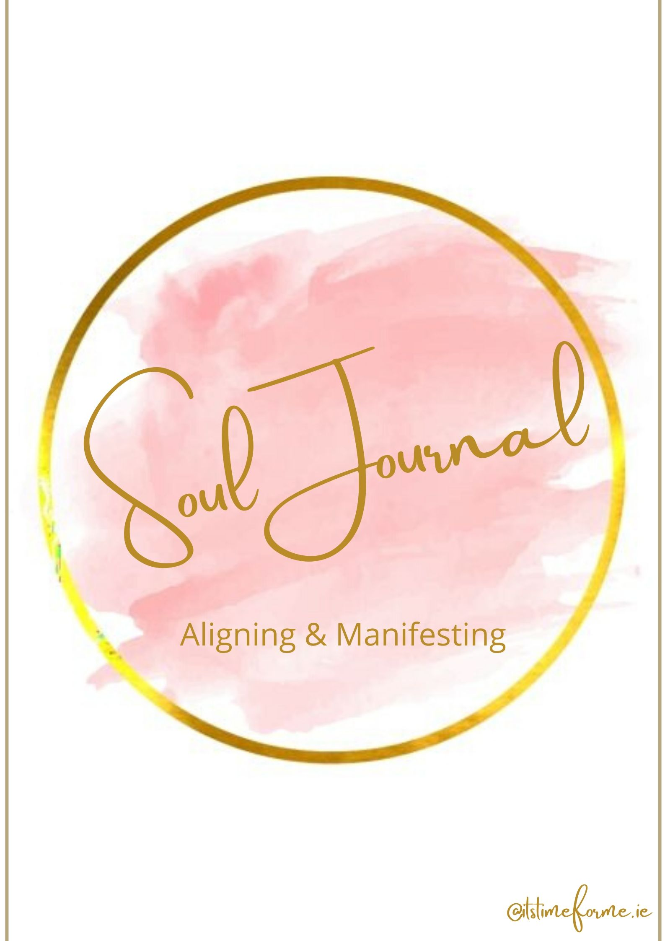
Well done on taking the time for yourself to journal and reflect. Writing is a powerful way to connect with your thoughts and emotions and offers you insight into how the next steps that your soul wants you to take. This is a really exciting month as you continue on the path of alignment with yourself and your desires so that you can manifest and create the magic of life!

When you think of being in alignment, what does this mean to you?
There is no wrong answer, just allow whatever thought comes up to flow onto the page.

When you think of being out of alignment, what does this mean to you?

Alignment is the process of being lined up, connected or in balance with your true self. That deeper part of you that holds the true wisdom and knowledge of who you are and know what is really right for you.

Are you taking a path in life that is leading you in the direction that will help you create the life that your desire or is it leading you in the direction that is taking you far away from the life that you desire?

Why?

What do you feel you need to do to being or continue the process of aligning with your true self and your desires?

What has been or is currently holding you back from doing so?

What is your current self-care practice like?

Do you devote enough time to your wellbeing?

If no, why not?

When you look at your present and future life, take some time to simplify things. What would a simplified and peaceful life look like to you?

Have you manifested good things in your life before?
If yes, what are they and how did you do this?

If no, have you tried to or have you not been able to?
If you have not been able to, what do you feel has blocked you?

When you think of the word ‘Manifesting’ what images and words do you associate with this?

Do you think you can manifest your desires?

What do you wish to manifest?

Soul Gathering – Manifesting Practice

At this month’s Soul Gathering (replay available) we will do a powerful manifesting practice that you can use again and again. These next few pages are to be used at the class.

