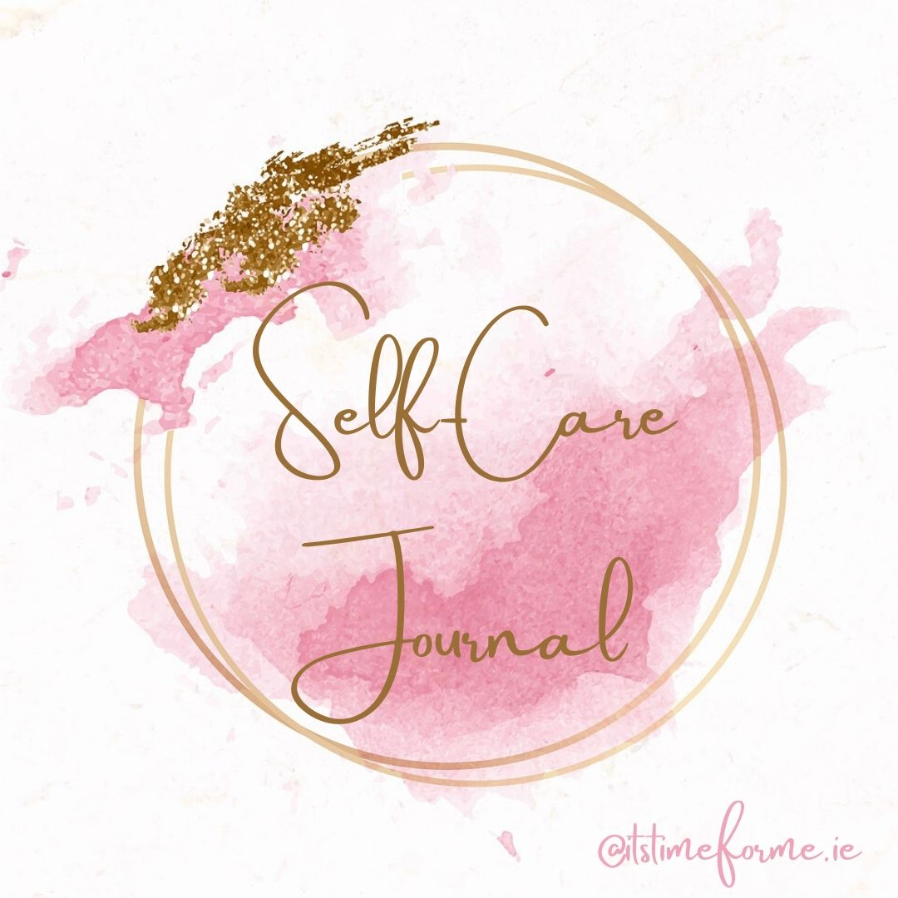

Before you begin….

Well done on taking the time for yourself to journal and reflect.

it would be lovely to take time to turn your journaling time into a ritual.

Find a quiet space and sit comfortably.
Light a candle and burn essential oils (safely).
Turn on some gentle and relaxing music.
Take your Journal and your favourite pen.

Allow your thoughts and emotions to come to the surface. Read each statement below and just allow whatever needs to come out to flow onto the page. Don’t judge what you are writing, allow yourself to have this time to get in connection with what you truly need to write and read.

I would like to improve my self-care because…………

I feel fearful and anxious when…….

The best things I can do for myself in these times are……

The things I love about myself are………

I am…

I need…….

I am ready for…..

I believe in myself because……

