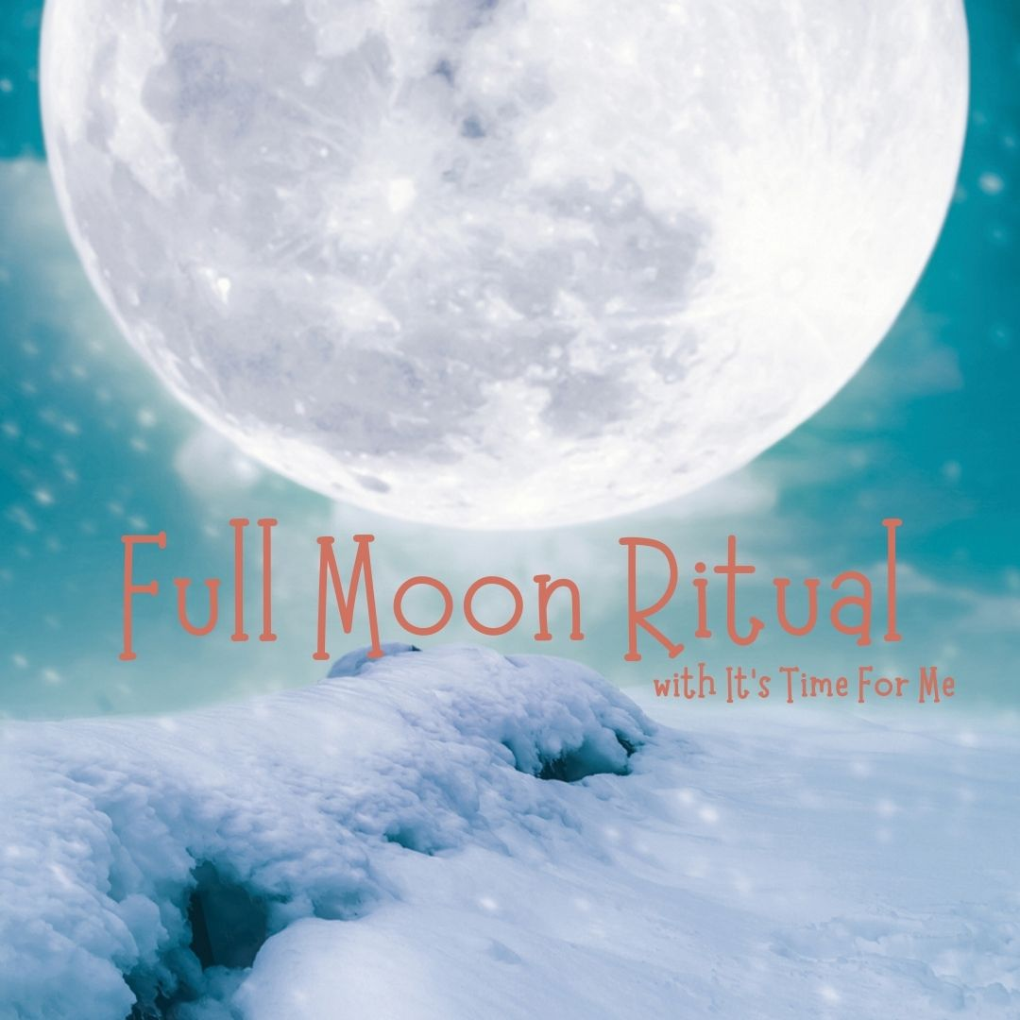

Wishing you a wonderful Full Moon, our last one of 2020. You can do this Ritual and Guided Meditation anytime over the 3 days from 29th December to 31st December. I hope you enjoy.

On this last Full Moon in December 2020 I am now ready to fully release and let go of………

This year I have learned that I am…….

I welcome in 2021 and will bring the following knowledge into my new year….

I am aware that I will encounter times of stress in my life again but I can calmly respond to this by……

2021 will be…..

“I let go because I know that I am strong, resilient and ready for happiness, abundance and comfort in life”.

