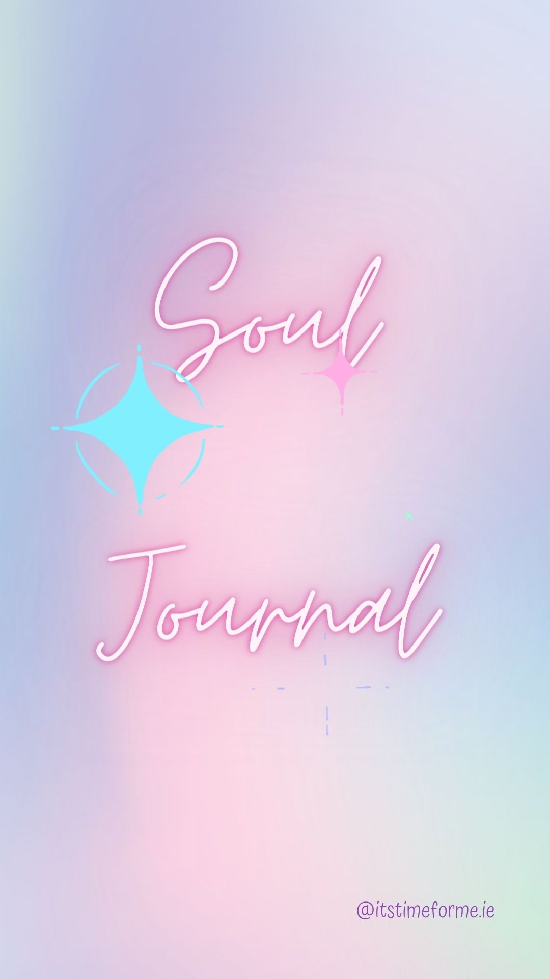
Wishing you a beautiful month ahead and offer gratitude to yourself now for taking this time to spend with yourself and listening to your inner knowing and inner voice.

Create a quiet and comfortable space for yourself, safely light a candle and put on some relaxation music. Let the pen and words flow, don’t judge what you are writing as it is all meant to be.

When I think of being intuitive I feel……….

I know that I have felt gut feelings before when…..

I don’t listen to my intuition because….

I listen to my intuition because….

Have you had positive experiences using your intuition before?

Intuitive Exercise
(This will be given to you in one of your weekly teachings. Use this space for that exercise.)

I feel in flow with life when….

I feel out of alignment with myself when…..

My intuition is currently telling me….

