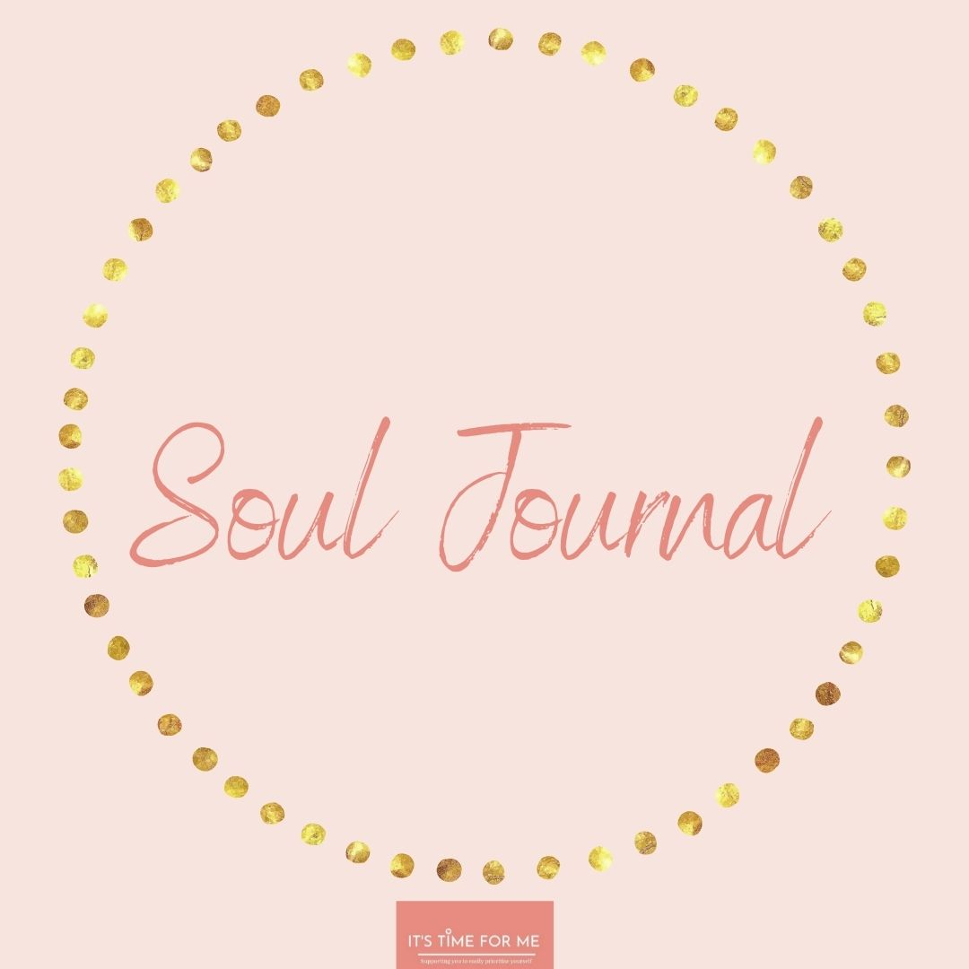
Wishing you a beautiful month ahead as we begin a month of 4 elements:
Gratitude
Mindfulness
The Nervous System
Affirmations/Mantras

Create a quiet and comfortable space for yourself, safely light a candle and put on some relaxation music. Let the pen and words flow, don’t judge what you are writing and be kind to yourself.

Gratitude
When have you felt frustrated and angry at life?

How has this made you feel in your body?

When have you felt happy and in sync with your life?

How has this made you feel in your body?

Have you ever been grateful for everything in your life in an attempt to avoid going for other dreams and goals that you have?
(I explain this in your teaching on 20th May 2021)

What does gratitude mean to you?

What are you grateful for? (Write as much as you can)

How can you create a gratitude practice in your life?

How do you feel this gratitude practice will help you?

Mindfulness
Do you show yourself loving kindness? If yes, why. If no, why?

Do you show others loving kindness? If yes, why. If no, why?

How do you think mindfulness can help you in your daily life?

What do you think being mindful means?

The Nervous System
I am leaving these next 3 pages blank as you will journal after you listen to the teachings on this section.

Affirmations
Do you believe in affirmations? If yes, why? If no, why not?

Create Your Own Affirmations

