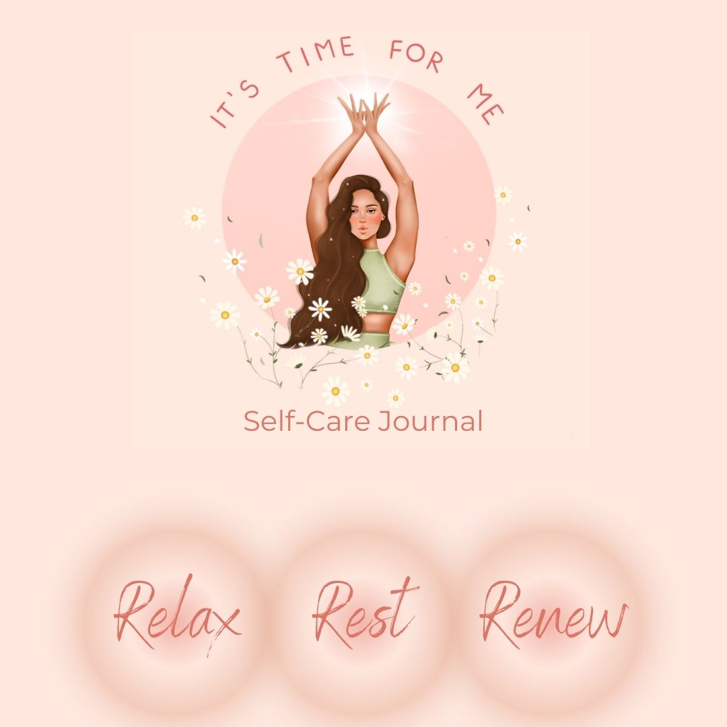

Welcome to your self-care journal, which you can use during this retreat and afterwards.
Often journaling can be something we avoid as we are not sure what to write. I would encourage you to be gentle with yourself, don’t judge your thoughts and allow your pen and thoughts/emotions flow onto the page. Try not to overthink it and allow what needs to come out on to the paper, to come out.
When you are journaling it can be helpful to find a quiet space, play some nice music, safely light a candle and take your time writing. Make a ritual out of it and afterwards read back at what you have written. It is a wonderful way to gain insights into your deeper feelings and emotions, which is really helpful in moving forward and progressing in life.

SELF-CARE
Take a moment now to think about what and write what parts of your life and yourself you are not minding as much as you need to.

Why do you feel you are not minding yourself in the way you need?

What support(s) do you need to help you?

What steps can you take to give yourself more self-care?

What parts of yourself, your life and your past need healing?

Do you avoid thinking about or dealing with these?
If yes, why? If no, why?

What do you hope for yourself in your life?

Do you have time for self-care?

Is there anyway of increasing this time or making time?

How do you think you would feel and how do you think your life would be if you could give yourself the attention and love that you need and deserve?

Do you have any other thoughts/emotions that you would like to write about in relation to your self-care

INTENTIONS
What are your intentions for the next 6 months ahead?

RELEASING
What do you feel you need to release and what are you ready to release?

CREATING
What do you wish to create in your life in the next 6 months and beyond?

YOUR BODY
How is your body feeling at this time?

What does it need?

What can you do to support it more?

JOURNAL PROMPTS
I am feeling…

I need…

My greatest wish is…

I worry about…

I feel grateful for…

I am happy about…

I need to love myself more because…

