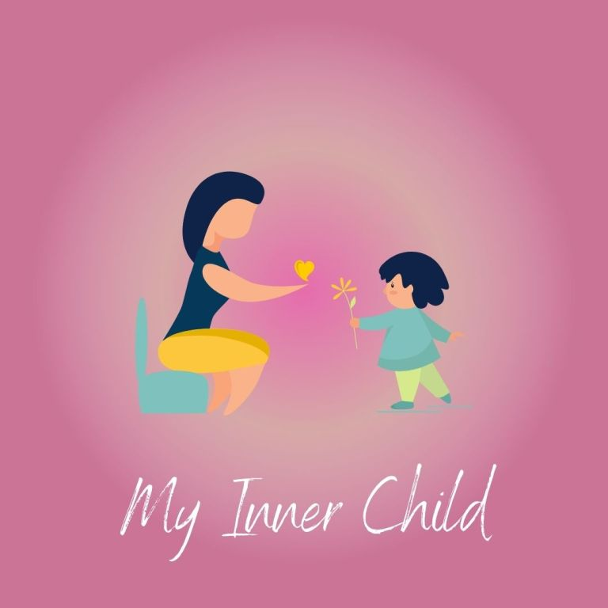
Wishing you a beautiful month ahead and offer gratitude to yourself now for taking this time to spend with yourself, connect with your subconscious and tap into the energy of your Inner Child.

Create a quiet and comfortable space for yourself, safely light a candle and put on some relaxation music. Let the pen and words flow, don’t judge what you are writing as it is all meant to be.

When I think of my inner child/younger self what comes to mind?

Do I feel that I was minded and looked after emotionally, mentally and physically in the way I needed when I was a child and why?

What part of my needs were not met when I was a child?

Do I recognise that my inner child comes out in my adult behaviours, reactions, responses and actions?

In what ways does this happen?

What do I feel I need to do to help heal my inner child?

What difficulties are you experiencing presently in your life?

Can you connect any of these present difficulties with the unhealed aspects of your inner child?

Are you ready to heal your inner child and why?

What age do you feel you were last your fullest and truest self?

Do you remember a time when you were younger that you were playful, fun, joyful, imaginative and creative?

Are you all or any of those things now? If yes, why? If no, why?

Are you ready to embrace that part of yourself?

